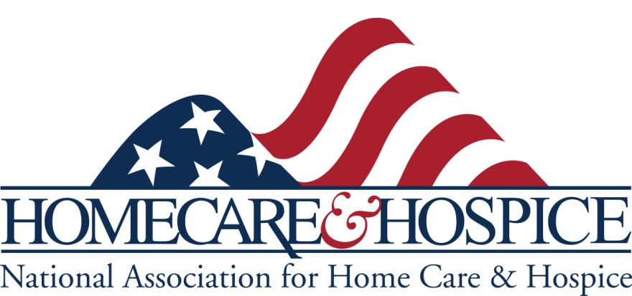
Guide for Cleaning and Disinfecting – COVID-19

*This Guide is provided in .doc format so providers can customize it for distribution to their patients.
This guidance provides recommendations on the cleaning and disinfection of households where persons under investigation (PUI) or those with confirmed COVID-19 reside or may be in self-isolation. It is aimed at limiting the survival of the virus in the environments. These recommendations will be updated if additional information becomes available.
These guidelines are focused on household settings and are meant for the general public.
- Cleaning refers to the removal of germs, dirt, and impurities from surfaces. Cleaning does not kill germs, but by removing them, it lowers their numbers and the risk of spreading infection.
- Disinfecting refers to using chemicals to kill germs on surfaces. This process does not necessarily clean dirty surfaces or remove germs, but by killing germs on a surface after cleaning, it can further lower the risk of spreading infection.
General Recommendations for Routine Cleaning and Disinfection of Households

Community members can practice routine cleaning of frequently touched surfaces (for example: tables, doorknobs, light switches, handles, desks, toilets, faucets, sinks) with household cleaners and EPA-registered disinfectants that are appropriate for the surface, following label instructions. Labels contain instructions for safe and effective use of the cleaning product including precautions you should take when applying the product, such as wearing gloves and making sure you have good ventilation during use of the product.
General Recommendations for Cleaning and Disinfection of Households with People Isolated in Home Care (e.g. Suspected/Confirmed to have COVID-19)
- Household members should educate themselves about COVID-19 symptoms and preventing the spread of COVID-19 in homes.
- Clean and disinfect high-touch surfaces daily in household common areas (e.g. tables, hard-backed chairs, doorknobs, light switches, remotes, handles, desks, toilets, sinks)
  - In the bedroom/bathroom dedicated for an ill person: consider reducing cleaning frequency to as-needed (e.g., soiled items and surfaces) to avoid unnecessary contact with the ill person.
    - As much as possible, an ill person should stay in a specific room and away from other people in their home.
    - The caregiver can provide personal cleaning supplies for an ill person’s room and bathroom, unless the room is occupied by child or another person for whom such supplies would not be appropriate. These supplies include tissues, paper towels, cleaners and EPA-registered disinfectants (see attached).
    - If a separate bathroom is not available, the bathroom should be cleaned and disinfected after each use by an ill person. If this is not possible, the caregiver should wait as long as practical after use by an ill person to clean and disinfect the high-touch surfaces.
- Household members should follow home care guidance when interacting with persons with suspected/confirmed COVID-19 and their isolation rooms/bathrooms.
How to clean and disinfect:

Surfaces
- Wear disposable gloves when cleaning and disinfecting surfaces. Gloves should be discarded after each cleaning. If reusable gloves are used, those gloves should be dedicated for cleaning and disinfection of surfaces for COVID-19 and should not be used for other purposes. Consult the manufacturer’s instructions for cleaning and disinfection products used. Clean hands immediately after gloves are removed.
- If surfaces are dirty, they should be cleaned using a detergent or soap and water prior to disinfection.
- For disinfection, diluted household bleach solutions, alcohol solutions with at least 70% alcohol, and most common EPA-registered household disinfectants should be effective.
  - Diluted household bleach solutions can be used if appropriate for the surface. Follow manufacturer’s instructions for application and proper ventilation. Check to ensure the product is not past its expiration date. Never mix household bleach with ammonia or any other cleanser. Unexpired household bleach will be effective against coronaviruses when properly diluted.
    - Prepare a bleach solution by mixing:
      - 5 tablespoons (1/3rd cup) bleach per gallon of water or
      - 4 teaspoons bleach per quart of water
  - Follow the manufacturer’s instructions for all cleaning and disinfection products (e.g., concentration, application method and contact time, etc.).
- For soft (porous) surfaces such as carpeted floor, rugs, and drapes, remove visible contamination if present and clean with appropriate cleaners indicated for use on these surfaces. After cleaning:
  - Launder items as appropriate in accordance with the manufacturer’s instructions. If possible, launder items using the warmest appropriate water setting for the items and dry items completely, or use of products with the EPA-approved emerging viral pathogens claims (see attached) are suitable for porous surfaces.

Clothing, towels, linens and other items that go in the laundry
- Wear disposable gloves when handling dirty laundry from an ill person and then discard after each use. If using reusable gloves, those gloves should be dedicated for cleaning and disinfection of surfaces for COVID-19 and should not be used for other household purposes. Clean hands immediately after gloves are removed.
  - If no gloves are used when handling dirty laundry, be sure to wash hands afterwards.
  - If possible, do not shake dirty laundry. This will minimize the possibility of dispersing virus through the air.
  - Launder items as appropriate in accordance with the manufacturer’s instructions. If possible, launder items using the warmest appropriate water setting for the items and dry items completely. Dirty laundry from an ill person can be washed with other people’s items.
  - Clean and disinfect clothes hampers according to guidance above for surfaces. If possible, consider placing a bag liner that is either disposable (can be thrown away) or can be laundered.
Hand hygiene and other preventive measures
- Household members should clean hands often, including immediately after removing gloves and after contact with an ill person, by washing hands with soap and water for 20 seconds. If soap and water are not available and hands are not visibly dirty, an alcohol-based hand sanitizer that contains at least 60% alcohol may be used. However, if hands are visibly dirty, always wash hands with soap and water.
- Household members should follow normal preventive actions while at work and home including recommended hand hygiene and avoiding touching eyes, nose, or mouth with unwashed hands.
  - Additional key times to clean hands include:
    - After blowing one’s nose, coughing, or sneezing
    - After using the restroom
    - Before eating or preparing food
    - After contact with animals or pets
    - Before and after providing routine care for another person who needs assistance (e.g. a child)
Other considerations
- The ill person should eat/be fed in their room if possible. Non-disposable food service items used should be handled with gloves and washed with hot water or in a dishwasher. Clean hands after handling used food service items.
- If possible, dedicate a lined trash can for the ill person. Use gloves when removing garbage bags, handling, and disposing of trash. Wash hands after handling or disposing of trash.
- Consider consulting with your local health department about trash disposal guidance if available.

Source: CDC, Environmental Cleaning and Disinfection Recommendations

Interim Recommendations for US Households with Suspected/Confirmed Coronavirus Disease 2019

